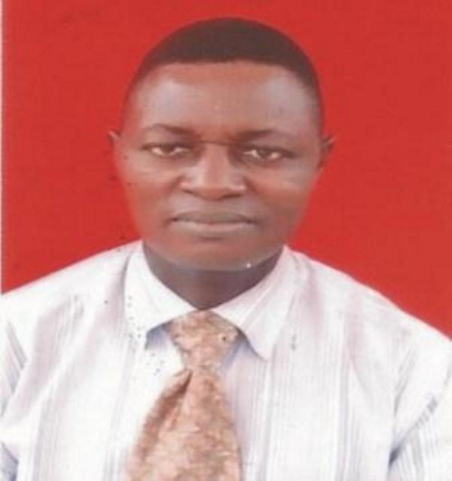
APPLICATION FOR DRILLING SUPERVISOR

NAME: HONOUR OSUWE

CONTACT ADDRESS: Olives Cresent , Olives Estate,
, Obodogwugwu Quarter, Okpanam,
Asaba, Delta State,
Nigeria.

PHONE: +2348059280051, + 2348033618175, +966537174182

EMAIL: honosuwe@yahoo.com.

DATE OF BIRTH: 18th January, 1974

NATIONALITY: Nigerian

OBJECTIVES A challenging Management Position in a
Drilling Department of Progression and Reputable
Mining/Petroleum Company that Offers
Opportunity.

(1) For Intellectual Thinking
(2) To Develop and Evaluate My Own Ideas
(3) To share My Ideas with others.

EDUCATION:
- NnamdiAzikiwe University, Awka, Anambra State,
Nigeria (1998 –2000)
- Ambrose Ali University, Ekpoma, Edo State,
Nigeria (1996 – 1998)
- Opencast Polytechnic, Benin City (1990 – 1992)
- Adaigbo Secondary School, Ogwashi-Uku, Delta State, Nigeria (1984 – 1989)

EDUCATION & PROFESSIONAL
QUALIFICATION:
- Postgraduate Diploma in Petroleum Geology (2000)
- Higher Diploma in Petroleum Engineering (1998)
- Ordinary Diploma in Drilling Engineering (1992)
- HUET CERTIFICATE
5 Well Control Certificate ( Supervisor’s) valid
6 West Africa School Certificate (1989)
7H₂S Course (2005).
8 Safety Leadership Course (2005)./ First Aid Course
* AdvanceFirefightingCourse,Abestor course,
* Drilling Technology (1) 2006

WORKING EXPERIENCE WITH DATES:

STERLING OIL AND GAS PRODUCTION - NIGERIA;
POSITION; (DRILLING SUPERVISOR;
DATE; 2014----------TILL DATE
LAND RIG

RESPONSIBILITIES; Supervise the entire drilling operations on behalf of client at the rig site, disseminate drilling operations details to the drilling contractor, ensure company’s ( client) policies are strictly follow by drilling contractor company. ensure that all third party arrive location on time prior to the commencement of their respective duty and supervise third party activities in drilling site, ensure that adequate safety procedure are been follow while discharging any job in the well drilling operations, plan for rig logistic for the well programme and ensure all require material arrive rig site on time,
Prepare /compile drilling report and final report on drilling/completion of wells.
Ensure the well is secure at all time , good well control practice and safety,

WEATHERFORD DRILLING INTERNATIONAL - SAUDI ARABIA;
POSITION( SENIOR RIG MANAGER)
2011------ 2014
LAND RIG

RESPONSIBILITIES; Plan and execute daily drilling activities, delegates crew for maximum duty discharge, ensure complete preventive maintenance plan is follow-up, coordinate with clients and third party for operations progress, ensure all documentation are being file into proper places, Maintain high level of safety standard, Plan and execute rig down, rig move and rig up as per plan etc.
Drill HTHP WELLS, horizontal wells and Training & monitoring rig crew.

NATIONAL DRILLING COMPANY – U. A. E
POSITION ( RIG MANAGER)
2009 ---------------- 2011
LAND RIG

RESPONSIBILITIES: In charge of entire drilling rig crew Plan, direct and coordinate the operations of the Rig.
Duties and responsibilities include formulating plans and schedules, managing daily operations, and planning the use of materials, crew machinery and equipment as per operations requirement.

OANDO ENERGY COMPANY (NIGERIA)
POSITION (TOOLPUSHER) 2007------------2009.
JACK UP RIG:

RESPONSIBILITIES: Ensure that the driller is provided with the standing instruction to driller (SID) that is relevant to the planned operations. Monitor the maintenance, repair and installation of all drilling equipment, including repair, lubrication, maintenance record and inventory.
Maintain record of inspection, classification of drilling equipment, tools, and tubular.
Ensure the mud mixing system and solid control are being monitored constantly and properly maintain.
Relieve the driller at the driller console as per operations requirement demands.
Partake in daily operations meeting with Drilling Supervisor ,OIM and other rig departmental heads.
Monitor the application of the company Rig Maintenance System (RMS) for drilling maintenance task.
Review and approve all drilling related permit to work as the responsible person for the task
Assist in planning job activities of the drilling department and associates activities.
Ensure that the well control equipment are in place according to operational demands; Assist in supervising well-killing operations in an emergency situations.
Perform well control calculation ,and maintain company policy.

ARABIAN DRILLING COMPANY (SAUDI ARABIA)
POSITION (SENIOR DRILLER) 2005-----------2007
JACK UP RIG:

RESPONSIBILITIES;

Assist Toolpusher in the drilling rig operations, Relieve driller in the driller console.
Perform well control calculation and ensure that all well control equipment are properly functioning; Testing blow –out preventer every 14 days interval.
Plan for rig move; ensure mast down /mast up are being execute in a safe manner.
Give in-house training to the drilling crew and ensure pre-job safety meeting is being organised before embarking on any task.
Maintain proper communication among all team players.

ARABIAN DRILLING COMPANY (SAUDI ARABIA)
POSITION ( ASSISTANTDRILLER) 2004------------ 2005

LAND RIG
RESPONSIBILITIES: For the efficient operation of the rig site as well as the safety of the crew. The role of supervision of work and control the major rig systems. Operates the mud pump, drumwork, and rotary table via the driller console, control the levers, rheostats, and other pneumatic, hydraulic and electronic instrumentation. Operates the drumwork brake using the long lever (conventional rig) or intelligent data display systems (ID3) or cyber chair system.
Use different types of top drive systems such as Varco, Tesco, Nov, and hydra-lift

PETROLOG DRILLING NIGERIA LIMITED
POSITION ( DRILLER ) 2002-2004
JACK –UP RIG
RESPONSIBILITIES: Handling drilling rig for oil well drilling operations, Ensure well is taken accurate fluid, while RIH/ POOH, Ensure crew safety, and equipment safety.
Actively participate in rig move and spudding well.

LONESTAR DRILLING COMPANY - NIGERIA
POSITION ( FLOORMAN, DERRICKMAN ASSISTANT DRILLER)
(2009 – 2004)
LAND RIG
RESPONSIBILITIES: Worked on the rig floor ;making connection/breaking connection, keep good housekeeping, maintenance of rig floor hand tools. Worked on derrick board, rigging up and down, assist driller in the driller console, make checklist etc

NATURE OF OPERATION:
- Drilling/workover/completion operations (Onshore/Offshore )

SPECIFIC SKILLS:
- Ability to communicate well at all levels
- Excellent Working Relations with Co-workers and General Public.
- High Motivation and Commitment to Deliver quality Service.

EXTRA CURRICULUM ACTIVITIES
SELF DESCRIPTION:
- Listening to cool Music, Travelling, Football, Driving and Swimming.
- Physical Agile, Ability to Effectively Work under pressure without Supervision in my area of Specialization, Ability to Travel at short Notice.
- Willingness to Commitment to Excellent Services.

LANGUAGE SPOKEN:
- Fluent in English and Igbo.

REFEREES:

MR. Nelson Oshionwu
No 2 Egbon Drive,
Erediawa Street,
Benin City,Nigeria,
Tel:08037472540

PROF. OLAJIAKA Mr ClementUbaru
Dean of Postgraduate Studies, Rig Supt,
NnamdiAzikiwe University, Awka, Arabian Drilling Com,
Anambra State, Nigeria. Saudi Arabian,
Ickachi1@yahoo.com

